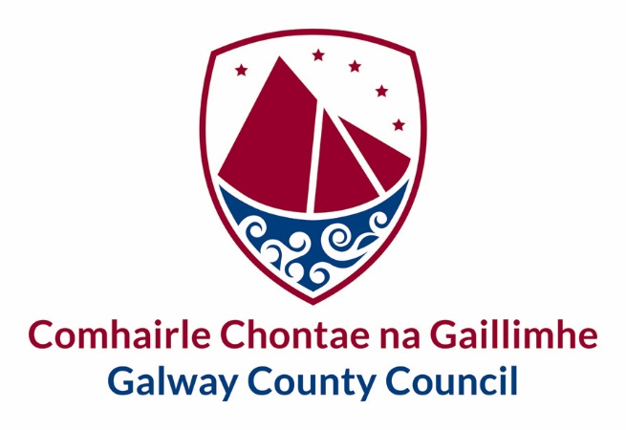

Standard Operating Procedure (SOP) – [Number Plate Recognition Camera’s - NPR]

Document Information

Document Title | Standard Operating Procedure – [Number Plate Recognition Camera’s - NPR]
Owner | Galway County Council
Author(s) | Data Protection Officer
Users | Galway County Council Staff and Citizens
Date | 11/12/20
Status | Adopted
Version | 1

Version History

Version | Created/Amended By | Date | Description
1 | Liadhan Keady | 11/12/20 | Standard Operating Procedure [Number Plate Recognition Camera’s- NPR]

Purpose

Galway County Council has deployed Number Plate Recognition (NPR) cameras in some housing estates under Community Based CCTV Section 38 An Garda Siochana Act 2005The purpose of NPR cameras is to mitigate anti-social behaviour, for the purposes of the safety of the community and the prevention of damage to Council property as outlined in the Council’s Anti-Social Behaviour Strategy.

Galway County Council’s NPR cameras are also in use for the purposes of law enforcement, in that data extracted from the CCTV cameras, is made available as evidence to the Environment Section for prosecutions under the following Acts:

- Waste Management Act 1996 (as amended)
- Litter Pollution Act 1997 (as amended)
- Protection of the Environment Act 2003 (as amended)

The NPR data is not cross referenced with NDLS information and therefore is not automatic in nature.
NPR technology has been in use for a number of years and proven to be effective.

Introduction

This procedure should be read in conjunction with Galway County Council’s CCTV Policy.
The purpose of the NPR deployment is to detect, deter and disrupt illegal activity, including anti-social behaviour and illegal dumping and therefore impact significantly on those involved in such activity.
In broad term’s the council will use NPR to:
- Increase public confidence and reassurance in the council
- Reduce Anti-Social behaviours
- Reduce crime and illegal activity
- Increase the detection of offences
- Make more efficient use of council resources

Data collection and storage is required to be assessed through a Data Protection Impact Assessment to ensure compliance.

NPR and their associated accessories have undergone a rigorous testing process to ensure that they are suitable for use by Galway County Council.

Scope
Galway County Council currently have CCTV systems installed in 7 estates, 2 of which have been upgraded to include NPR cameras to which this procedure applies. Please refer to Appendix 7 which provides an inventory of CCTV camera’s installed by Galway County Council across County Galway and their current operational status.

Systems and Recording
There is appropriate signage in place confirming that CCTV cameras are operational and includes details of the Data Controller.
The data collected is not paired with other information that becomes personally identifiably until an incident has been detected that requires enforcement under the applicable legislation. This requires an approval process with an audit trail.
The data is not subject to automatic scanning or reading and the vast amount of data collected will not be viewed and will therefore not routinely intrude on an individual’s privacy.
For Galway County Council’s Housing Unit, the NPR deployment is essentially capturing car registration details only and there is no matching of data, automated or otherwise.
All matching / cross-referencing, to identify car owners, is done on request only in accordance with Galway County Council’s CCTV Policy.

Privacy
The data is not subject to automatic scanning or reading and the vast amount of data collected will not be viewed and will therefore not routinely intrude on an individual’s privacy.
The data collected is not paired with other information that becomes personally identifiably until an incident has been detected that requires enforcement under the applicable legislation.

Data

Access to NPR systems including storage devise and storage media is restricted to authorized personal and logged.
Access to each CCTV and its recordings shall be restricted to the Designated Employee and other personnel that have authorised access to the system. Access Logs shall be maintained by the Designated Employee that has responsibility for each CCTV system. The logs shall maintain a record of all requests made by Data Subjects and An Garda Síochána to view/obtain copies of CCTV recordings and the outcome of such requests.
The storage medium used by the CCTV system should be kept in a secure location. Where feasible, access to CCTV Hub rooms will be controlled via Maglock.

The CCTV system in use provides the following Data Security measures:
- Fully encrypted control communication
- Transport layer security Secure Remote Password (TLS-SRP) for client-server connections
- Automatic firmware updates
- No backdoor administrative or maintenance access accounts
- Signed and encrypted firmware
- Centralized user control through Active Directory integration and/or parent/child user sharing
- Password strength enforcement
- Ability to bulk-change camera passwords from Avigilon Control Center (ACC) software
- Lock-out on multiple invalid login attempts

All matching / cross-referencing, to identify car owners, is done on request only in accordance with Galway County Council’s CCTV policy.

In relevant circumstances, CCTV footage can be accessed and a copy released subject to the relevant application being made to the following:

- Data Subjects or their legal representatives - pursuant to an access request under the Data Protection Acts, where the time, date and location of the recordings is furnished to the Council
- An Garda Síochana - on request in writing when a crime or suspected crime has taken place and / or when it is suspected that illegal / anti-social behaviour is taking place on Council property or in a public place
- Director of Services - to assist the relevant Director in establishing facts in alleged cases of unacceptable behaviour
- Individuals (or their legal representatives) – subject to a Court Order
- Council Insurers - to pursue a claim for damage done to the Council’s insured property.

Galway County Council’s CCTV Data release form must be completed in respect of CCTV Data Recording and /or Transfer.

The release of CCTV footage to An Garda Síochana in relation to Community Based CCTV under Section 38 of the Garda Síochána Act, 2005, is governed by a Memorandum of Understanding between An Garda Síochána and Galway County Council.

Monitoring

This procedure is subject to the same monitoring / review arrangements as described in the parent policy (Galway County Council’s CCTV Policy).

The procedure will be reviewed as required.

